5. SEPARATION OF SUBSTANCES
D. Long answer:
1. What is the difference between homogenous and heterogeneous mixtures? Give an example of each mixture.
S.no | Homogenous mixture | heterogeneous mixture
1. | It has a uniform composition | It has a non-uniform composition
2. | It has only one phase | There are two or more phases
3. | It can’t be separated out physically | It can be separated out physically
4. | We can’t judge a homogeneous mixture by just seeing it | We can judge a heterogeneous mixture by just seeing it
5. | Example: a mixture of alcohol and water | Example: a mixture of sodium chloride and sand

2. List three properties of mixtures.
The three properties of mixtures are
i. The constituents of a mixture may be in any ratio.
ii. The constituents retain their individual properties.
iii. The constituents can be separated by simple methods
3. Give two situations where it is necessary to separate a mixture into its constituents.
(i) To remove undesirable constituents for example, harmful substances present in river water.
(ii) To obtain useful constituents for example, butter can be obtained from milk or curd by churning it.
4. Draw a labelled diagram to show the arrangement used to filter a mixture of a liquid and an insoluble solid.

5. Draw a labelled diagram of the apparatus used to distil out pure water from a solution.
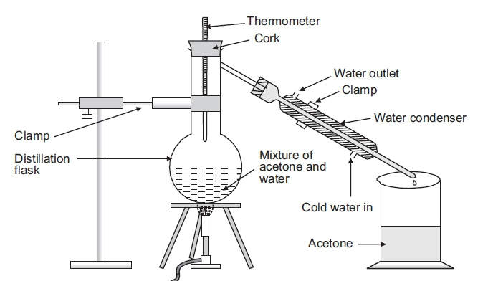

6. How will you separate a mixture of grass, pebbles and sand?
- We remove pebbles by hand picking.
- Grass can be separated by filtration and sand can be separated by sedimentation and decantation

7. Explain with the help of a diagram how can a mixture of oil and water be separated.
- Pour oil and water in a separating funnel and let it stand for some time. You can clearly see two layers – water at the bottom and oil on top.
- Carefully turn the stopper of the funnel and allow the water to flow out into a beaker placed below the funnel. Stop the flow as soon as the layer of oil reaches the stopper.
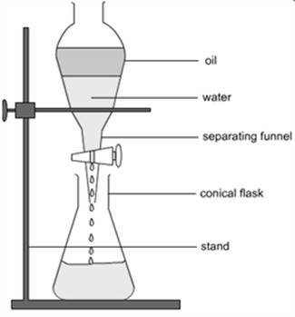

8. Why is water considered as an important solvent?
- In the process of digestion, food is reduced to simple substances that are soluble in water.
- They can then be dissolved in water and absorbed by the body. Several waste materials produced in the body are dissolved in water and excreted.
- A number of chemical reactions occur inside our body. They all occur in the presence of water.
- Plants can absorb nutrients from the soil only if they are soluble in water.
- Minerals from the roots and food from the leaves are transported to different parts of the plant in the form of solutions in water.

